**Mini Project Report on**



**Augmented Reality-based Virtual Tour Guide**



**Submitted in partial fulfilment of the requirement for the award of the degree of**

**BACHELOR OF TECHNOLOGY**

**IN**

**COMPUTER SCIENCE & ENGINEERING**

**Submitted by:**

**Student Name**  **University Roll No.**

**Harshit Dutt Tyagi 2018825**

***Under the Mentorship of***

**Mr. Arnav Kotiyal**

**Assistant Professor**



**Department of Computer Science and Engineering**

**Graphic Era (Deemed to be University)**

**Dehradun, Uttarakhand**

**July-2023**



**CANDIDATE’S DECLARATION**

I hereby certify that the work which is being presented in the project report entitled **“Augmented Reality-based Virtual Tour”** in partial fulfillment of the requirements for the award of the Degree of Bachelor of Technology in Computer Science and Engineeringof the Graphic Era (Deemed to be University), Dehradun shall be carried out by the under the mentorship of **Mr. Arnav Kotiyal, Assistant Professor**, Department of Computer Science and Engineering, Graphic Era (Deemed to be University), Dehradun.

**Table of Contents**

|  |  |  |
| --- | --- | --- |
| **Chapter No.** | **Description** | **Page No.** |
| Chapter 1 | Introduction | **1-2** |
| Chapter 2 | Literature Survey | **3-5** |
| Chapter 3 | Methodology | **6-7** |
| Chapter 4 | Result and Discussion | **8-9** |
| Chapter 5 | Conclusion and Future Work | **10** |
|  | References | **11** |

**Chapter 1**

**Introduction**

* 1. **Problem Statement: -**

To increase the Tourism to a place (Ex -Rajasthan) using Augmented Reality. There are many heritage sites which lack tourism and many of such sites also do not have Tourist Guides. In such cases tourists didn’t get to know the Culture and history of that properly and communication in language except Hindi and English is always a problem.

* 1. **What is Augmented Reality? :-**

The word "augment" refers to the process of improving something by adding to it, which is how the term "augmented reality" is formed. Therefore, augmented reality is essentially a technique for modifying our real world by adding certain digital components to it. This enhances the sense of reality by superimposing a digital image on the person's current vision.

* 1. **Objectives Of Project: -**
* This project aims to provide Globalization of various Heritage sites which will grow tourism industry exponentially.
* To achieve Globalization, we use Augmented Reality as a tool and try to integrate it we the tourism websites and applications of various states.
* To know the History and culture of the place using Augmented Reality.
* To remove the language barrier in Communication for tourists visiting a heritage site.
  1. **Difference Between Augmented Reality and Virtual Reality: -**

|  |  |
| --- | --- |
| **Augmented Reality** | **Virtual Reality** |
| Augmented reality just adds the virtual components into the user’s real-world view. | Virtual reality makes a virtual environment and puts the user in it. |
| For Augmented reality you only need a modern smartphone then you can easily download an AR app like Google’s “**just a line**” and try this technology. | In this, all you have to do is insert a smartphone, wear a headset (like **Oculus Rift** or a gaming console like **PlayStation VR**), and immerse yourself in virtual reality |

**Table 1.1 Difference between Augmented Reality and Virtual Reality**

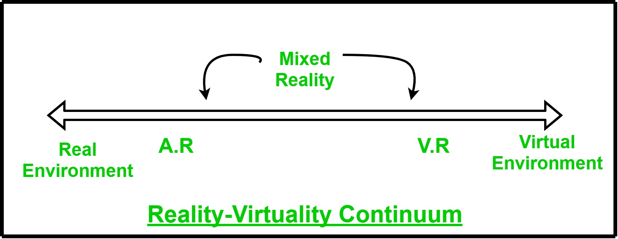

**Figure 1.2 Reality-Virtuality Continuum**

Paul Milgram introduced the reality-virtuality continuum as a rating system. A scale with two extremes is used. This scale includes all possibilities for one object or plane to be completely digital or completely real. One part depicts "virtuality" or an environment that is entirely virtual, the other part describes a real environment or "reality," and the middle part is referred to as "mixed reality."

**Chapter 2**

**Literature Survey**

* 1. **History: -**

1. A cinematographer by the name of Morton Heilig initially accomplished augmented reality in some capacity in 1957. He created the Sensorama, which provided the spectator with sights, sounds, vibrations, and smells. Of course, it wasn't computer-controlled, but it was the first instance of an effort to enrich an experience with more information.
2. In 1980, computational photography researcher Steve Mann introduced wearable computers. Of fact, Jaron Lainer and Thomas P. Caudill of Boeing were the first to use the names in 1990 and 1989, respectively, so these weren't "virtual reality" or "augmented reality" back then.
3. Louis Rosenberg's AR system, created in 1992 at USAF Armstrong's Research Lab, was likely the first one to operate effectively. This extremely sophisticated robotic system, known as Virtual Fixtures, was created in the early 1990s to make up for the absence of high-speed 3D graphics processing capability. It made it possible for sensory information to be overlaid on a workspace to increase worker efficiency.

Between this point and the present, there have been numerous further advancements in augmented reality, the most significant of which are:

• Bruce Thomas created the outdoor mobile AR game AR Quake in 2000.

• The release of the design tool AR Toolkit in Adobe Flash in 2009.

• In 2013, Google revealed the open beta for their Google Glass project, which had mixed results.

• In 2015, Microsoft announced that its HoloLens augmented reality headset would enable the technology.

## **2.2 The National Museum of Singapore**

1. In museum spaces, AR has been equally successful. In the National Museum of Singapore, an immersive installation called Story of the Forest received critical praise. This exhibit focuses on 69 images from the William Farquhar Collection of Natural History Drawings.

https://www.youtube.com/watch?v=OMv92DpcgfI

[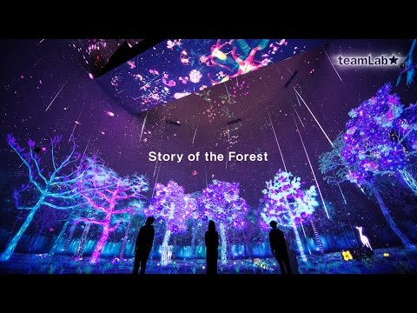](https://www.youtube.com/embed/OMv92DpcgfI?feature=oembed)

## **2.3 Microsoft and the Kyoto National Museum**

1. AR can bring tech brands and artistic centres together, as was the case with Microsoft and the Kyoto National Museum. The cooperation produced an immersive exhibition highlighting the artwork of Kennin-ji, Japan's oldest Zen monastery.

https://www.youtube.com/watch?v=pWh0LbiQVhk

[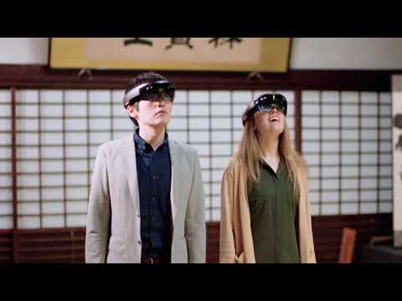](https://www.youtube.com/embed/pWh0LbiQVhk?feature=oembed)

## **2.4 Bridge Trails**

1. The UK's Clifton Suspension Bridge is a great place to see AR in action today. The Bridge Trails app was created to improve user experience on the website and let users enjoy audio and visual material at fifteen different locations on and around the well-known bridge.
2. One of the worries that museum and cultural professionals have about AR is that it might serve as a distraction from the actual exhibit. Although there is some merit to this fear, there are many examples of how AR has already been used to enhance tourist experiences with expertise and great sensitivity. And it would be fair to say that as the use of AR advances and becomes more commonplace, the integration of such innovative tools into heritage sites and museum installations will become ever more seamless.

**Chapter 3**

**Methodology**

**3.1 Augmented reality offers museums the opportunity to bring history to life: -**

Over the past few years, augmented reality, or AR, has quickly entered our daily lives. Previously dismissed as nothing more than a science fiction invention, augmented reality is now a simple button press away. or, more frequently, by tapping the screen of a smartphone. Of course, gaming platforms have seen some of the most popular AR tech implementations.

**But what about the potential effects of using such technology in museum settings, particularly in relation to cultural sites?**

**GLOBALIZATION**

**OF CULTURAL HERITAGE**

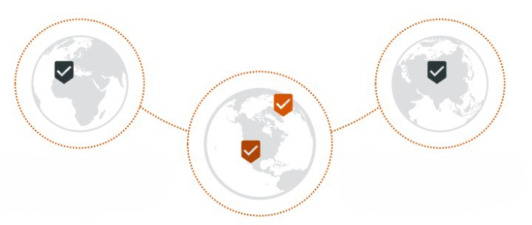

* Cultural heritage's tourism business will experience exponential growth. It cannot be done without the use of technology.
* With the help of our AR application, we hope to accomplish this. Digitally disseminating Rajasthani culture will lead to revolutionary change.

**3.2** **AUGMENTED REALITY TOUR: -**

**Working and Features of my App: -**

* It will be an android app which will have all relevant details related to tourism i.e., Transportation, Fest & Food, Luxury Tour Packages etc.
* User can create his tour plan in this app. When s/he visits some place s/he just needs to play tour of that place.
* As soon as user plays tour, AR version of application will open. It will navigate the user. The user can see 3D models of monuments, descriptions of different artifacts/paintings through voice and text.
* There will be unique QR-codes scanning which will open an AR virtual guide. It will narrate the information in users’ preferable language.
* When the user will point camera at any object/painting it will create 3-D model of that.

**Chapter 4**

**Result and Discussion**

**4.1 What have I implemented?**

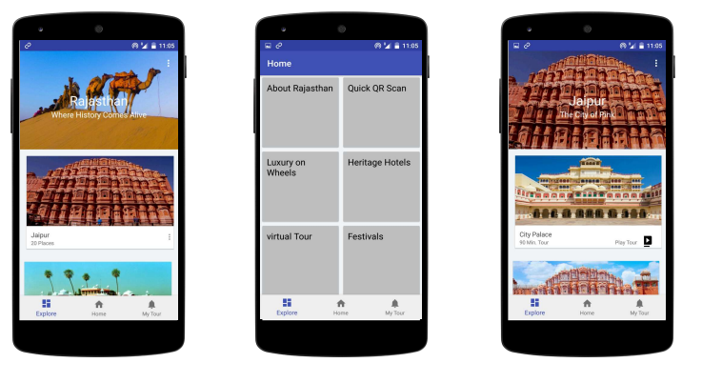

**Figure 4.1 Rajasthan’s App for Various Cultural Sites**

* Here the above Interface for tourism application is implemented in Android Studio with the help of JAVA programming language the images of various Heritage sites are taken from google just to represent various places which can be visited by a tourist in Rajasthan.
* I had given three main activities to give basic functionalities in the application. From these, tourists will be able to make their whole plan to visit the various places among Rajasthan and can have a virtual tour of the place using Augmented Reality by clicking Play Tour icon.

**Figure 4.2 Augmented Reality Guide for Tourists**

* Here the above Augmented Reality app which displays the model of Taj Mahal is made in Unity Editor along with Vuforia Engine.
* It also used the image tracking feature of unity to overlay the 3D Model over the displayed image.
* After Displaying 3D model over the image, it will also narrate the history of that heritage site and will stop narrating when the image is removed from tracking AR Camera.

**Chapter 5**

**Conclusion and Future Work**

**5.1 Conclusion: -**

The proposed Android app aims to provide comprehensive tourism information, including transportation options, festivals, food, and luxury tour packages. Users can create their tour plans within the app. During their visits, they can access a guided tour of each place using augmented reality (AR) technology. The AR version of the app will display 3D models of monuments and provide descriptions of artifacts and paintings through both voice and text. The app will also feature unique QR codes that, when scanned, will activate an AR virtual guide, presenting information in the user's preferred language. Furthermore, pointing the camera at objects or paintings will generate 3D models of the selected items.

**5.2 Future Work: -**

1. To integrate each Heritage site with the entire AR app. in order for the tourist guide to be available everywhere.
2. To make more 3D models available in applications, as there aren't many of them for heritage sites.
3. Increase the application's functionality to allow users to see their complete tour itinerary for a certain location.
4. 360-degree tours of surrounding restaurants and motels should be added so that users may make their own decisions.
5. For better identification of Heritage sites, integrate it with the official tourism website.
6. a complete transaction functionality that enables travelers to find a one-stop solution to all their problems.
7. Luxury and vehicles from companies should be included so that lodging and transportation do not become an issue.

**References**

[1] [What can AR do to bring heritage sites to life? - MuseumNext](https://www.museumnext.com/article/what-can-ar-do-to-bring-heritage-sites-to-life/)

[2] [Augmented Reality – The Past, The Present and The Future | IxDF (interaction-design.org)](https://www.interaction-design.org/literature/article/augmented-reality-the-past-the-present-and-the-future)

[3] [(645) Vuforia Unity Tutorial - Image Targets #2 - YouTube](https://www.youtube.com/watch?v=-bF0oxgtt6A)

[4]<https://www.google.com/url?sa=t&source=web&rct=j&url=https://free3d.com/3dmodels/ar&ved=2ahUKEwjZ1e_omAhUObmwGHboACfkQFnoECBMQAQ&usg=AOvVaw0oShfOrmV6v5zhndYnL_UX>

[5][Basics of Augmented Reality - GeeksforGeeks](https://www.geeksforgeeks.org/basics-augmented-reality/)